**ANNUAL TOP FIVE**

**EXECUTION VENUE REPORT 2024**

**TRADING YEAR 2023**

April 30th 2019

Contents

INTRODUCTION 3

CONTENT OF THE REPORT 3

Overview of the quantitative reports 3

Scope of the report 4

General disclosure about qualitative assessment 4

REPORTING BY INSTRUMENTS 7

Equities – Shares & Depositary Receipts 7

Debt instruments – Bonds 12

Debt instruments – Money market instruments 13

Interest Rates Derivatives – Futures and options admitted to trading on a trading venue 14

Interest Rates Derivatives – Swaps, forwards and other interest rates derivatives 15

Credit Derivatives – Other credit derivatives 16

Currency Derivatives – Futures and options admitted to trading on a trading venue 17

Currency Derivatives – Swaps, forwards and other currency derivatives 17

Equity Derivatives – Futures and options admitted to trading on a trading venue 19

Equity Derivatives – Swap and other equity derivatives 20

Securitized Derivatives 21

Contract For Difference 21

Exchange traded products 21

SECURITIES FINANCING TRANSACTIONS (SFT) 23

Repo and Reverse Repo 23

DISCLAIMER 25

# INTRODUCTION

In accordance with Markets and Financial Instruments Directive and Regulation (MIFID II/MIFIR), BNPP PARIBAS Dealing Services (“Dealing Services”), as investment firm, is required to publish an annual report regarding the quality of execution top 5 venues in term of trading volumes for all executed clients orders per class of financial instruments.

This report is presenting the top 5 venue reports per class of instrument for the trading year 2023 as required and described in the Regulatory Technical Standard RTS 28 of MIFIR (Delegated regulation C(2016) 3337 final) and in the COMMISSION DELEGATED REGULATION (EU) 2017/576.

# CONTENT OF THE REPORT

## Overview of the quantitative reports

RTS 28 requires to report per class of instruments the top 5 venues and display the following data:

* venue name and identifier;
* volume of client orders executed on that execution venue expressed as a percentage of total executed volume;
* number of client orders executed on that execution venue expressed as a percentage of total executed orders;
* percentage of the executed orders that were passive and aggressive orders;
* percentage of orders that were directed orders;
* Confirmation of whether it has executed an average of less than one trade per business day in the previous year in that class of financial instruments.

Dealing Services provides both the services of execution and reception-transmission of orders depending on the type of instrument and /or the type of order and/or the parameters of the order. One report must be produced per instrument and per type of investments services provided by Dealing Services.

The following table shows all classes of instruments handled by Dealing Services in 2023 and the type of services provided by Dealing Services (execution and/or transmission):



N.B 1: If the line is grey, it means that Dealing Services has not traded these instruments in 2023.

Equity instruments must be classified according to their liquidity as determined under the tick size regime as set out in Directive 2014/65/EU of the European Parliament and the Council. There are three liquidity categories known as “bands”. As Dealing Services has traded shares of the three bands either executing or transmitting, six separate Top 5 Venue tables are published in this document.

## Scope of the report

The report includes

* all transactions executed or transmitted by Dealing Services in 2023
* all transactions delegated to BNP PARIBAS AM UK, BNP PARIBAS AM ASIA and BNPP AM US and that have been executed or transmitted by the local dealing desk of these entities on behalf of Dealing Services orders in 2023

## General disclosure about qualitative assessment

The RTS 28 requires, for each class of instruments, a summary of the analysis and conclusions Dealing Services draw from its detailed monitoring of the quality of execution obtained on the execution venues where it has executed all client orders in 2023.

Some of the requirements apply to all instruments and are commented below. Some will be detailed instruments by instruments.

1. an explanation of the relative importance the firm gave to the execution factors of price, costs, speed, likelihood of execution or any other consideration including qualitative factors when assessing the quality of execution;

A major part of Dealing Services trading activity of Dealing Services is directly performed under the European Union regulations; as such, traders have to comply with MiFID requirements, especially those related to best selection and execution. In all local trading desks of BNP PARISBAS Asset Management entities to which Dealing Services can delegate the execution of orders (BNPP AM UK, BNPP AM Asia and BNPP AM US), MiFID requirements will be respected throughout these entities as long as they are not in contradiction with local regulations.

As principles defined by its execution policies to meet MiFID II best execution requirements, executing clients' orders using either trading venues or counterparties and brokers authorised by its clients, BNP Paribas Dealing Services generally takes into account several parameters which can be combined or not and may vary according to the instrument types, as described below:

* Price of the instrument
* Potential market impact
* Market liquidity & conditions
* Order size & order type
* Likelihood of execution
* Speed of execution
* Likelihood of settlement
* Direct and/or indirect transaction costs
* Specific client instructions
* Counterparties trading capacities combined with competitive pricing & qualitative coverage as per their overall performances defined by our detailed ranking (cf. point (d) below)
* Legal documentation

Transactions are executed with the pre-selected intermediaries that are the best match for these criteria, which are ranked differently depending on the financial instrument and the order type.

1. a description of any close links, conflicts of interests, and common ownerships with respect to any execution venues used to execute orders;

Dealing Service is fully owned subsidiary of BNP Paribas Asset Management. Dealing Services may use BNP Paribas group’s affiliated brokers/counterparties. According to internal compliance procedures, the in-house brokers will be subject to the same broker selection and evaluation process and rules as any other broker/counterparties and receives no preferential consideration.

Dealing Services does not have any links or conflict of interest with trading venues.

1. a description of any specific arrangements with any execution venues regarding payments made or received, discounts, rebates or non-monetary benefits received;

Dealing Services does not have any specific arrangements with any execution venues regarding payments made or received discounts, rebates or non-monetary benefits. Dealing Services may receive minor material non-monetary benefits from execution venues and these are only accepted after Dealing Services have made consideration in line with its regulatory obligations and with its own internal procedures.

1. an explanation of the factors that led to a change in the list of execution venues listed in the firm’s execution policy, if such a change occurred;

Trading Platforms:

Platforms to be used are selected based on the following criteria:

* Traded products
* Operational efficiency
* Liquidity access

Hereafter is a non-exhaustive list of the main platforms currently used within Dealing Services trading desks:

* Liquidnet (Equity and Fixed Income)
* ITG POSIT (Equity)
* Tradeweb (Equity and Fixed Income)
* TSOX (Fixed Income)
* MarketAccess (Fixed Income)
* FXAll (Forex)
* CBOE / LIS (Equity, added in 2018 to have a better access to the available buy side liquidity)

Counterparties and brokers:

Dealing Services does not determine the list of Counterparties and Brokers with which it is authorised to work; the clients give the list.

Twice a year, Dealing Services evaluates the quality of the execution services provided by the brokers and the counterparties with whom it has worked. Each intermediary is evaluated and noted according to a set of quantitative and qualitative criteria (electronic offer, market coverage and instruments, proposed prices, liquidity provided, post trade follow-up...). This evaluation is communicated to clients.

The results of this execution vote are used, among other criteria, on a daily basis as part of the best selection of the brokers/counterparties and the best execution processes.

Brexit

To answer the Brexit challenges, Dealing Services has switched gradually in 2020 trading with UK market intermediaries to their EUR based entities. This is why several entities of a same corporate group can appear in the top 5 venues reports, displacing other brokers/counterparties that are used on a regular basis on the 6th or 7th rank.

In that case, so as to provide additional information on the other market intermediaries chosen for execution that are deemed relevant to Dealing Services’ order execution practices, the report will list the top 6 or top 7 venues.

For the trading platforms, which have also been migrated to the EUR based entities, executions done on both UK and EUR platforms have been gathered to show the actual part of execution done on platforms.

1. an explanation of how order execution differs according to client categorisation, where the firm treats categories of clients differently and where it may affect the order execution arrangements;

* All Dealing Services’ clients are professional clients. All clients’ orders are dealt with the same diligence.

1. an indication that other criteria have been favoured, or not, over the price and the immediate costs of executing orders from retail clients, and an explanation of how these other criteria have been decisive in achieving the best possible result in terms of total cost for the customer.

* Dealing Service has no retail client.

1. an explanation of how the investment firm has used any data or tools relating to the quality of execution, including any data published under Delegated Regulation (EU) 2017/575.

* Will be detailed instrument by instruments.

1. where applicable, an explanation of how the investment firm has used output of a consolidated tape provider established under Article 65 of Directive 2014/65/EU.

* Dealing Services does not use output of a consolidated tape provider.

1. where applicable, disclose the identity of the main venues investment firm commonly selects via DEA arrangements and the existence of any close links and specific arrangements with such execution venues.

* Dealing Services does not select venue via DEA arrangements.

# 

# 

# REPORTING BY INSTRUMENTS

## Equities – Shares & Depositary Receipts

The traders who determine which execution factors are most important and, therefore the strategy to employ in order to obtain the best possible result assess each order.

With the aim of getting the best execution price, Dealing Services traders takes into account, the execution cost (brokerage costs) agreed between the clients and their brokers.

After the nature of the order, the price (including implicit cost) is usually the execution factor the traders consider to be most important when dealing in equities, although speed is also an important factor when they want to take advantage of a particular price observed in the market, or to avoid an adverse market impact if the order is large in size or the market is volatile.

The execution factors are generally driven by the price and order size, and then the likelihood of execution (market liquidity and conditions), speed of execution and the settlement arrangements.

The vast majority of shares orders handled by Dealing Services are transmitted to brokers and will appear in the transmission reports of the different liquidity bands.

The shares orders that are executed directly by the trading desks corresponds to less liquid shares or larger sizes that may be executed on conditionnel venues that matches interests on an anonymous basis or are bilaterally executed with a broker(s) that has published Indication Of Interest, who has the reverse interests and who offers the best execution conditions.

It is up to the negotiator to use the different modes of execution offered by brokers and counterparties (blocks, trading algorithms, program trading...)

For the three liquidity bands and for execution and transmission services, Dealing Services uses TCA (Transaction Cost Analysis) analysis to monitor its execution performance and control execution quality. For each transaction, execution price is compared to a benchmark price value provided by an independent TCA data provider. Reference benchmarks have been selected by order type to obtain the most effective, fair and coherent benchmarking results. Deviations from benchmarks above pre-determined threshold are all justified by traders.

Execution quality is regularly reviewed by Dealing Services desks (first level controls), Compliance teams (second level controls) and with the client‘s investments strategy teams.

1. ***Execution reports***

**Liquidity band 5 to 6 corresponds to an average daily number of transactions from 2000 trades per day (as defined under the tick size regime as set out in Directive 2014/65/EU).**

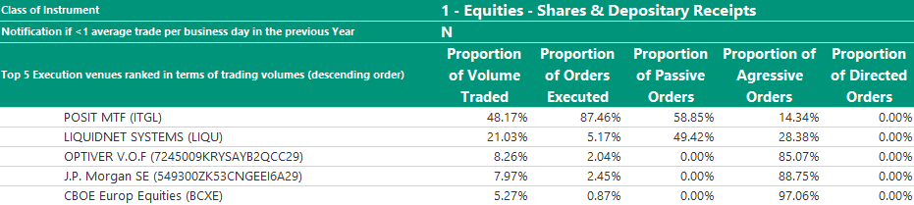

The MTF (Multilateral Trading Platform) “POSIT” is ranked first in the report followed by Liquidnet Systems. This trading platform being a platform that matches interests on an anonymous basis to minimize the possible impact of orders in the market, the only counterparty that Dealing Services is facing is Liquidnet EU limited (entity opened for Brexit purpose).

We have access with these two platforms to sell side and buy side liquidity pools. In this category, we have exposed a large range of our flows Large caps and Small & Mid-caps.

This year, Posit MTF is the platform that we use for a large part of our orders included in this category. Liquidnet Systems ranks the second place in terms of volumes traded and passive orders. It has clearly progressed in particularly for aggressive orders. Optiver V.O.F is in third place.

Top 5 counterparties on Posit MTF

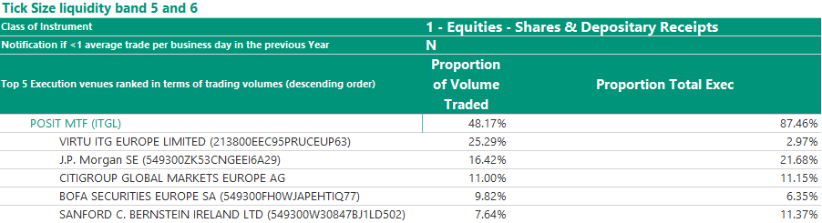

Regarding the Posit MTF, The Virtu ITG Europe Limited liquidity pool was the most active, the other four brokers represent around 45% of the volumes traded.

Top 5 counterparties on Liquidnet Systems

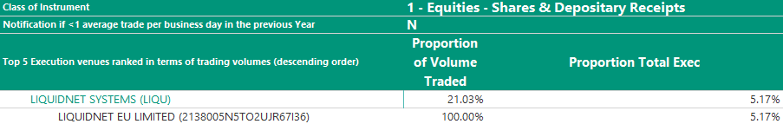

We only deal with the European entity Liquidnet. Its volume decreased compared to last year.

**Liquidity band 3 to 4 corresponds to an average daily number of transactions from 80 trades to 1999 trades per day (as defined under the tick size regime as set out in Directive 2014/65/EU).**

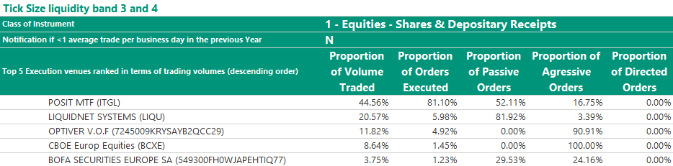

The MTF (Multilateral Trading Platform) “POSIT” is ranked 1. This year Liquidnet is ranked second with a majority of passive orders.

In 2023, we used execution venues Posit MT, Liquidnet Systems and Bofa Securities for passive strategies for the execution orders with lower liquidity than the previous category.

Top 5 counterparties on Posit MTF

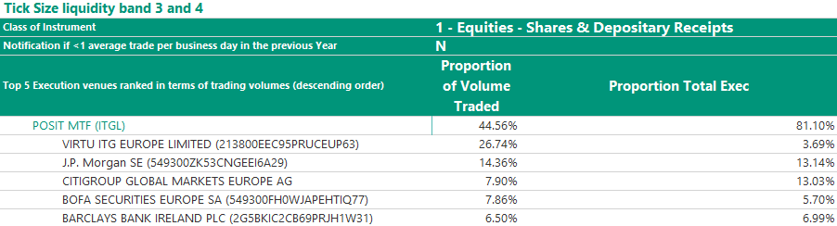

We have dealt more than 40% of orders in this category. Virtu ITG is the most active venue with nearly 27% of volumes traded, J.P Morgan, Citigroup, Bofa Securities and Barclays for around 35% of the volumes traded on Posit MTF.

Top 5 counterparties on Liquidnet Systems

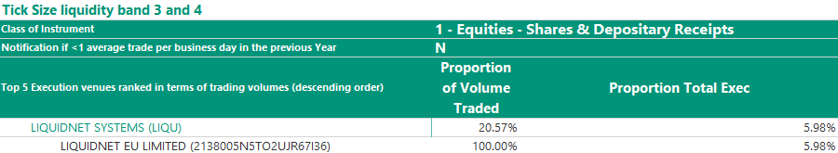

Regarding Liquidnet, we only deal with the European entity Liquidnet.

**Liquidity band 1 to 2 corresponds to an average daily number of transactions less than 80 trades per day (as defined under the tick size regime as set out in Directive 2014/65/EU).**

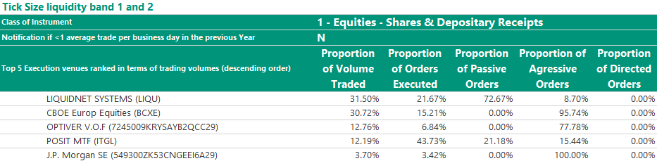

For the last category, Liquidnet is the first counterparty with a majority of passive orders. This trading platform being a platform that matches interests on an anonymous basis to minimize the possible impact of orders in the market, the only counterparty that Dealing Services is facing is Liquidnet EU limited (entity opened for Brexit purpose).

CBOE ranked in second position had the largest part of orders executed aggressively.

Top 5 counterparties on Liquidnet System

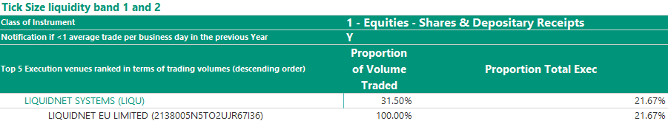

We only deal with the European entity Liquidnet. The volume has decreased compared to 2022.

Top 5 counterparties on CBOE Europ Equities

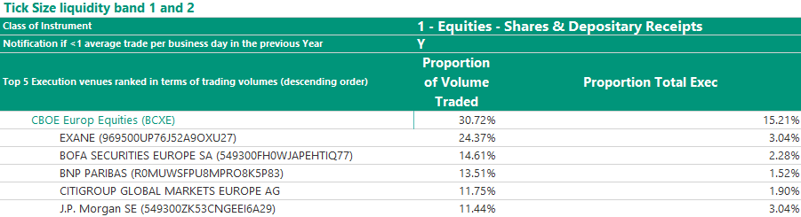

CBOE accounts for more than 30% of orders for this category with the leading group Exane, Bofa Securities and BNP Paribas for about 52% of volumes followed by Citigroup and J.P. Morgan for just less than 12% each.

1. ***Transmission reports***

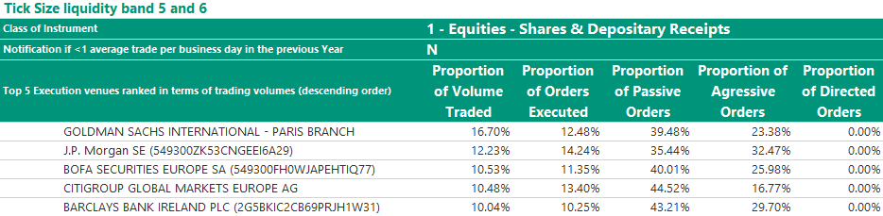

Compared to 2022, the top 5 counterparties remain the same. They account for more than 50% of the volumes traded with a greater proportion of passive orders than aggressive orders especially for Citigroup.

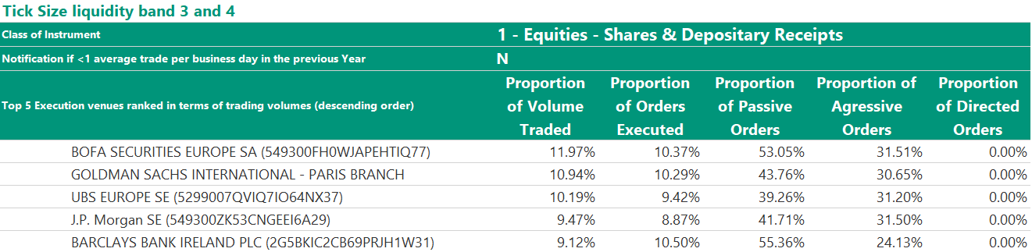

Same observation, more than 50% of the volumes dealt by the first five venues. There are four counterparties present from last year ranking (Goldman Sachs, J.P. Morgan, Barclays and Bofa Securities).

The proportion of passive orders is always higher than the aggressive orders.

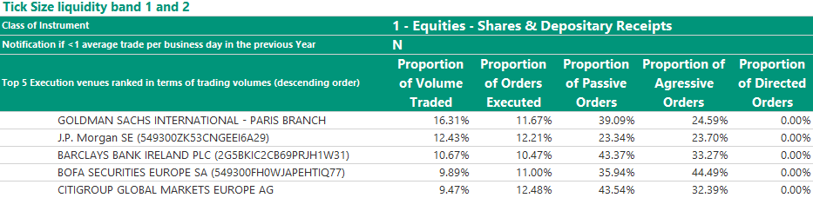

For the less liquid order category, a predominance of Goldman Sachs and Anglo saxon banks with even more passive orders than aggressive orders.

## Debt instruments – Bonds

1. ***Execution report***

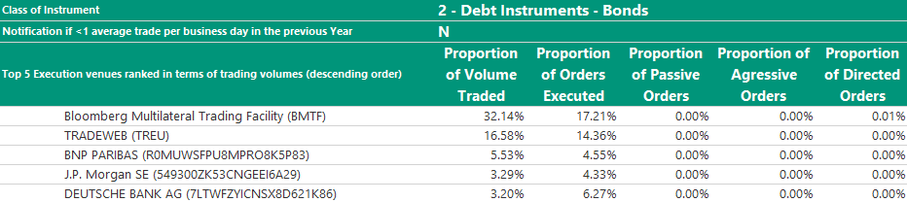

The MTF Bloomberg TSOX is ranked first. This trading venue enables to perform electronic STP (Straight Through Processing) Request For Quotes to a broad range of counterparties that are authorized by the clients. The use of trading plateforms minimizes operationnal errors, enhances the access to liquidity and the execution quality.

Trading is conducted following the RFQ process. Executions on Debt instruments are generally driven by the price and order size, and then market liquidity and conditions, speed of execution and likelihood of settlement.

In order to complete orders, liquidity may become the most important factor. This is relevant when the order is of a large size for the market or for a security with limited availability. The composition of the top 5 trading venues changed this year to include J.P. Morgan and Deutsche Bank. We use Tradeweb and Bloomberg MTF to trade electronically a broad range of debts such T-bills and bonds in secondary markets.

Tradeweb and TSOX keep their place. These both platforms total around 50% of volumes traded. BNP Paribas, J.P. Morgan and Deutsche Bank total 12% of the volumes. Our traders have a broad range of eligible Counterparties to trade within this classification of delivery versus payment (DVP) instruments.

As our Counterparties capacity to provide competitive prices (liquidity) changes over time, our traders adapt their Counterparty selection and thus we would expect the composition and order of the top 5 venues to be also dynamic. Our Execution policy provides traders with a framework in terms of selecting an appropriate number of Counterparts given the characteristics of the order and a requirement to document a reason on our audit trail, which justifies executions where less than 3 quotes have been recorded.

This is particularly relevant in parts of the market where specific bonds have reached a point in their maturity so that they are no longer widely quoted or traded. Our traders have access to a trading tool, which consolidates and sorts Counterparty bond axes in real time. The tool identifies axed Banks or Brokers, which can be incorporated into Counterparty selection for any given trade, providing the trader with the opportunity to negotiate a super execution price.

Less liquid bonds, orders with larger size or other specific orders may have to be traded off venue (telephone or IB Chat) as they require more interaction between the traders and the counterparties. As much as possible, the traders perform an RFQ process if it doesn’t lead to information leakage on the market.

In some cases, Dealing Services may not be in a position to organise a request for quotes or may consider that it is inappropriate to do so in the client's interests, which provides a de facto justification that the price criterion has been adhered to.

Without drawing up a comprehensive list, this may occur in the following circumstances:

* a need to guarantee maximum confidentiality;
* the illiquidity of the financial instrument;
* any situation where the request for quotes is contrary to the clients' interests.

For Bonds, Dealing Services uses two kinds of report to perform controls and monitor its execution performance.

* A ‘RFQ’ report highlighting competing quotes received from counterparties and justifications when execution prices differ from best quotes of if there have been insufficient number of quotes.
* A report based on TCA (Transaction Cost Analysis) analysis. For each transaction, execution price is compared to a benchmark price value provided by an independent TCA data provider.

Execution quality is regularly reviewed by Dealing Services desks (first level controls), Compliance teams (second level controls) and with the client ‘s investments strategy teams.

Top 5 counterparties on Bloomberg TSOX :

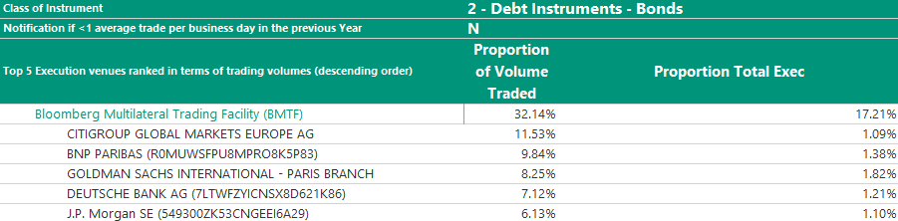

The top five counterparties total a little less than 43% of the volume, with a fairly close distribution of volumes.

The counterparty Deutsche Bank join the top 5 this year. J.P. Morgan remains in the ranking with a slight drop of volume traded.

Top 5 countreparties on Tradeweb :

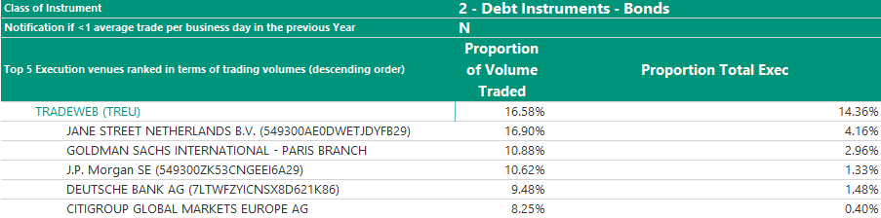

As for the previous platform the counterparties have a fairly close distribution of volumes with Jane Street as an exception recording 17% of the volumes traded. We note the introduction of Goldman Sachs and Citigroup in this top five.

Top 5 counterparties on MARKETAXESS EUROPE Limited:

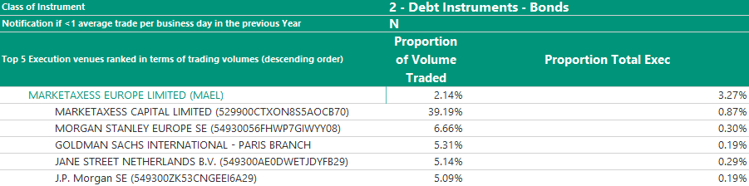

## As for the previous platform the counterparties have a fairly close distribution of volumes around 6% exception done for Marketaxess with its 39%.

## Debt instruments – Money market instruments

1. ***Execution report***

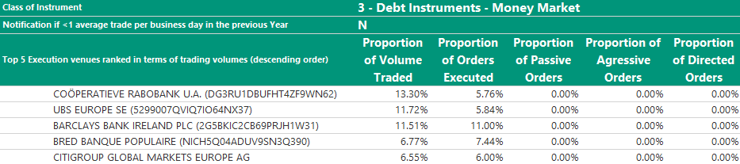

Similar to last year, Cooperatieve Rabobank, UBS, BRED and Barclays are still on the top five. Citigroup entered in the top five this year.

Executions on Money Market instruments are generally driven by the price and order size, and then market liquidity and conditions, speed of execution and likelihood of settlement.

Main activity is done off venue (telephone, IB Chat), due to the nature of the Money Markets instruments. As much as possible, the traders perform an RFQ process if it doesn’t lead to information leakage on the market.

In some cases, Dealing Services may not be in a position to organise a request for quotes or may consider that it is inappropriate to do so in the client's interests, which provides a de facto justification that the price criterion has been adhered to.

Without drawing up a comprehensive list, this may occur in the following circumstances:

* a need to guarantee maximum confidentiality;
* the illiquidity of the financial instrument;
* any situation where the request for quotes is contrary to the clients' interests.

To perform its controls for Money Market, Dealing Services uses a ‘RFQ’ report highlighting competing quotes received from counterparties (including justifications when execution prices differ from best quotes of if there have been insufficient number of quotes).

Execution quality is regularly reviewed by Dealing Services desks (first level controls), Compliance teams (second level controls) and with the client‘s investments strategy teams.

## Interest Rates Derivatives – Futures and options admitted to trading on a trading venue

Executions on Interest Rates Listed Derivatives instruments are generally driven by the price and order size, and then market liquidity and conditions, speed of execution and likelihood of settlement.

The majority of Interest Rates Listed Futures and Options are transmitted to brokers for execution.

Execution services done by the traders correspond to the case when the trader has to rollover a position: depending on different factors, the dealer may organize an RFQ process to get the best possible results.

1. **Execution report**

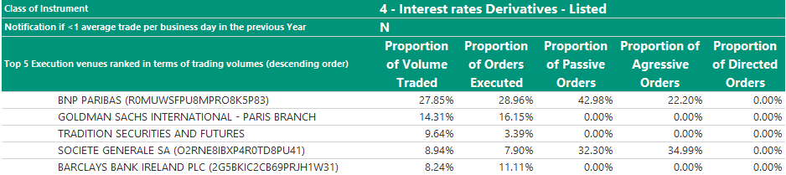

We are trading for this category with a mix of Banks and Brokers. The majority of the volumes was traded with brokers. This year, Bofa Securities replaced Tradition Securities and Futures.

1. **Transmission report**

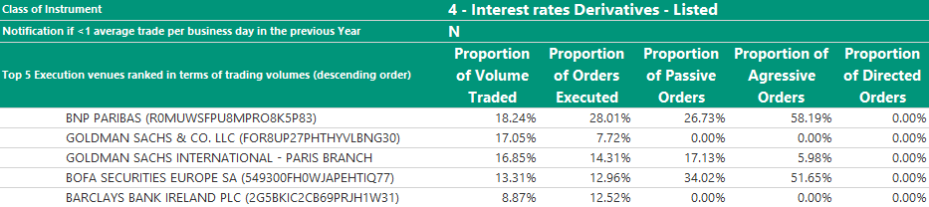

We are trading for this category with a mix of Banks and Brokers. This year, Barclays replaced Tradition Securities and Futures.

## 

## Interest Rates Derivatives – Swaps, forwards and other interest rates derivatives

1. **Execution report**

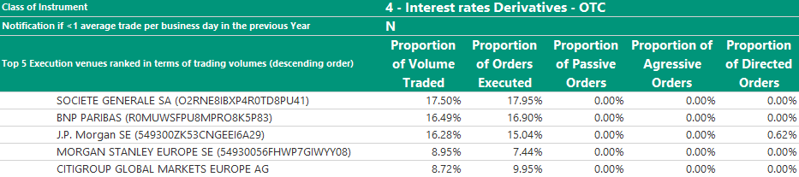

We traded over the counter (OTC) swaps and IRS in this category of financial instrument.

Our traders focus mainly on price, and request RFQ’s from different counterparties depending on where they expect liquidity to be available. In order to complete orders, liquidity can be a factor in relation to less liquid swaps or large in size orders.

You will notice a concentration of volumes traded on the five counterparties with a predominance of HSBC followed by BNP Paribas and Citigroup which total around 22% of volumes. We find the same counterparties as the previous year with a significant decline for J.P Morgan. Citigroup and Barclays replaced Goldman Sachs and Société Générale.

As with other OTC products, our list of authorized OTC derivative Counterparts comprises major banks that have satisfied our criteria to protect clients from settlement risk and includes the execution of ISDA/CSA documentation to support Bilateral trading or Clearing agreements.

We have adapted our trading architecture so that we are ready to meet modified US and European regulations which require changes to how we clear, trade, report and record eligible derivative contracts.

Executions on Interest Rates Derivatives instruments are generally driven by the price and order size, and then market liquidity and conditions, speed of execution and likelihood of settlement.

The trading activity can be done off venue (telephone, IB Chat), due to the nature of the instruments. As much as possible, the traders perform an RFQ process if it doesn’t lead to information leakage on the market.

In some cases, Dealing Services may not be in a position to organise a request for quotes or may consider that it is inappropriate to do so in the client's interests, which provides a de facto justification that the price criterion has been adhered to.

Without drawing up a comprehensive list, this may occur in the following circumstances:

* a need to guarantee maximum confidentiality;
* the illiquidity of the financial instrument;
* any situation where the request for quotes is contrary to the clients' interests.

## 

## Credit Derivatives – Other credit derivatives

1. **Execution report**

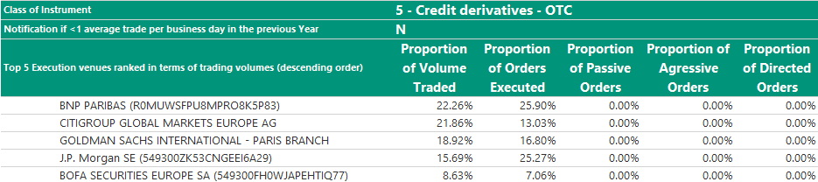

This year, Bofa Securities entered the top 5 counterparties replacing Morgan Stanley. We can notice a greater concentration of volumes on this top 5, with a sharp increase in Goldman Sachs’ market share compared to 2022.

Executions on Credit Derivatives instruments are generally driven by the price and order size, and then market liquidity and conditions, speed of execution and likelihood of settlement.

All the trading activity is done off venue (telephone, IbChat), due to the nature of the instruments. As much as possible, the traders perform an RFQ process if it doesn’t lead to information leakage on the market.

In some cases, Dealing Services may not be in a position to organise a request for quotes or may consider that it is inappropriate to do so in the client's interests, which provides a de facto justification that the price criterion has been adhered to.

Without drawing up a comprehensive list, this may occur in the following circumstances:

* a need to guarantee maximum confidentiality;
* the illiquidity of the financial instrument;
* any situation where the request for quotes is contrary to the clients' interests.

## Currency Derivatives – Futures and options admitted to trading on a trading venue

Executions on Currency Listed Derivatives instruments are generally driven by the price and order size, and then market liquidity and conditions, speed of execution and likelihood of settlement.

The majority of Currency Listed Futures and Options are transmitted to brokers for execution.

Execution services done by the traders correspond to the case when the trader has to rollover a position: depending on different factors, the dealer may organize an RFQ process to get the best possible results.

1. **Execution report**

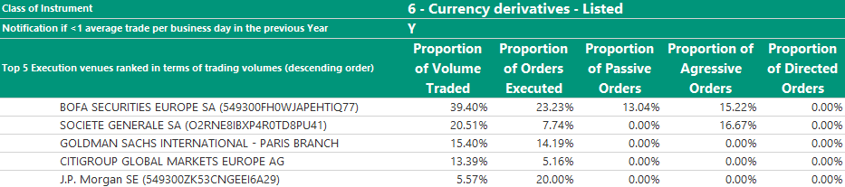

The top four counterparties represent more than 88% of the volume traded, Bofa Securities for around 40% of the volume and more than 23% for the proportion of the orders executed, followed by Société Générale with 20.51% of the volumes and 7.74% of the executed orders. Then, we have Goldman Sachs with 15.40% of the volumes and 14.19% of orders executed. It should be noted that Bofa Securities and Société Générale have opted for aggressive strategies.

1. ***Transmission report***

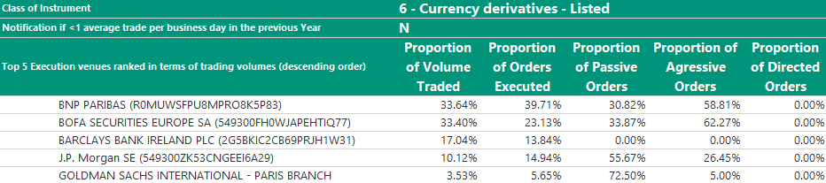

For the transmission report, BNP Paribas is still the number one with around 34% of the volumes and more than 39% of the orders, Bofa Securities with 33.40% of the volumes and 23.13% of the orders. Then, we have Barclays with 17.04% of the volumes and 13.84% of the executed orders. It should be noted that BNP Paribas and Bofa Securities have opted for aggressive strategies while J.P. Morgan and Goldman Sachs have preferred passive strategies.

## Currency Derivatives – Swaps, forwards and other currency derivatives

1. **Execution report**

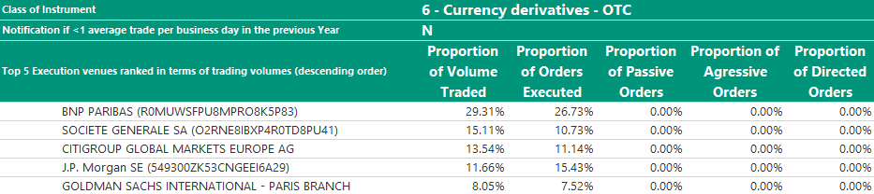

In comparison to 2022, Goldman Sachs replaces FXALL MTF in this top five. The other counterparties remain the same.

We predominantly execute transactions in foreign exchange forwards, swaps, non-deliverable forwards and OTC currency options using an RFQ process. Price is usually the most important factor when we select which counterparty to trade with. For Fixing orders each counterparty has to offer the same price, hence cost is the most important factor.

It is a fiduciary responsibility to protect our Clients from FX settlement risk. Our list of authorized Counterparts comprises major banks that have met specific requirements we have set out in terms of acceptable financial strength, proven market share, and price competitiveness. As a result, our list of Counterparts for these financial instruments is purposefully selective.

In order to complete orders, liquidity can be a factor for less liquid currency pairs or where market conditions are challenging. Having pre-arranged credit lines or limits in place can also be a factor in precluding some client orders from trading at the best price provided by the RFQ process.

Where we employ algorithms to achieve the best result, counterparties are chosen given the strategy and suitability of the algorithm.

Executions on Forex instruments are generally driven by the price and order size, and then market liquidity and conditions, speed of execution and likelihood of settlement.

In the top 5 venues, BNP Paribas account for around 29% of the traded volumes followed by Société Générale with 15.11%. J.P. Morgan is ranked third with 13.54%.

This trading venue enables to perform electronic STP (Straight Through Processing) . The use of trading plateforms minimizes operationnal errors and enhances the access to liquidity and the execution quality.

When we use electronic trading venues, we are able to ask a greater number of our Counterparties for quotes at the same time and then select the best price. Using this process is a more efficient way to deliver best execution, which explains the high percentage of orders traded using the FX ALL platform.

Less liquid currency pairs, orders with larger size or other specific orders may have to be traded off venue (telephone, IB Chat) as they requires more interaction between the traders and the counterparties. As much as possible, the traders do an RFQ process if it doesn’t lead to information leakage on the market.

In some cases, Dealing Services may not be in a position to organise a request for quotes or may consider that it is inappropriate to do so in the client's interests, which provides a de facto justification that the price criterion has been adhered to.

Without drawing up a comprehensive list, this may occur in the following circumstances:

* a need to guarantee maximum confidentiality;
* the illiquidity of the financial instrument;
* any situation where the request for quotes is contrary to the clients' interests.

As a part of our trading framework, we monitor our trading efficiency by employing continuous trade cost analysis (TCA) and by conducting periodic reviews of Counterparties, which incorporate hit ratio competitiveness studies.

For Currency OTC derivatives, Dealing Services uses two kinds of report to perform controls and monitor its execution performance.

* A ‘RFQ’ report highlighting competing quotes received from counterparties and justifications when execution prices differ from best quotes of if there have been insufficient number of quotes
* A report based on TCA (Transaction Cost Analysis) analysis. For each transaction (except for OTC currency Options), execution price is compared to a benchmark price value provided by an independent TCA data provider. Deviations from benchmark are monitored according to pre-determined thresholds.

Execution quality is regularly reviewed by Dealing Services desks (first level controls), Compliance teams (second level controls) and with the client‘s investments strategy teams.

Top 5 counterparties on FXALL

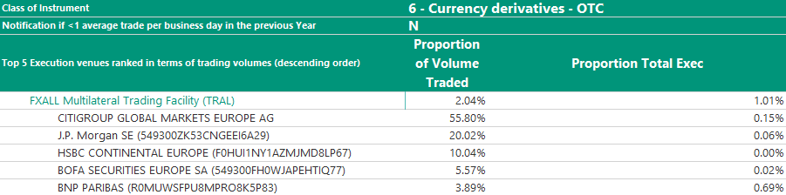

This year, HSBC joins the top 5 execution venues replacing Société Générale.

## 

## Equity Derivatives – Futures and options admitted to trading on a trading venue

Executions on Equity Listed Derivatives instruments are generally driven by the price and order size, and then market liquidity and conditions, speed of execution and likelihood of settlement.

The majority of Equity Listed Futures and Options are transmitted to brokers for execution.

Execution services done by the traders correspond to the case when the trader has to rollover a position: depending on different factors, the dealer may organize an RFQ process to get the best possible results.

1. **Execution report**

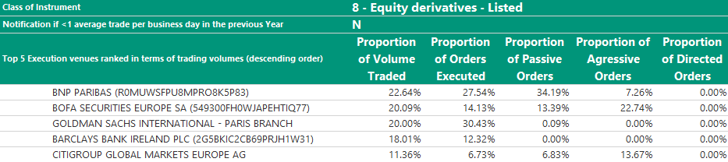

BNP Paribas is the first in the top five with around 23% of the volumes and 28% of executed orders, followed by Bofa Securities with 20.09% of the volumes and around 14.13% of the executed orders. Ranked third Goldman Sachs accounts for 20% of the volumes and 30.43% of executed orders. Barclays and Citigroup represent around 30% of the volumes and around 19% of the executed orders.

1. **Transmission report**

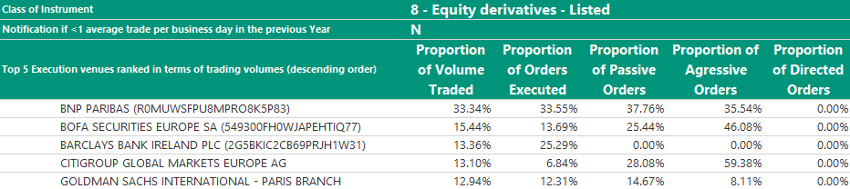

For the transmission report in this category, BNP Paribas is the first counterparty with 33.34% of the volumes. The other counterparties have an equivalent distribution of volumes. Bofa Securities accounts for 15.44% followed by Barclays with 13.36% of volumes, Citigroup 13.10% and Goldman Sachs 12.94% respectively. In terms of executed orders, BNP Paribas is also first with more than 33%, then 25.29% for Barclays, Bofa Securities with 13.69% and Goldman Sachs and Citigroup for 12.31% and 6.84% respectively.

## Equity Derivatives – Swap and other equity derivatives

Executions on Equity Derivatives instruments are generally driven by the price and order size, and then market liquidity and conditions, speed of execution and likelihood of settlement.

The trading activity may be done off venue (telephone, IB Chat), due to the nature of the instruments. As much as possible, the traders perform an RFQ process if it doesn’t lead to information leakage on the market.

In some cases, Dealing Services may not be in a position to organise a request for quotes or may consider that it is inappropriate to do so in the client's interests, which provides a de facto justification that the price criterion has been adhered to.

Without drawing up a comprehensive list, this may occur in the following circumstances:

* a need to guarantee maximum confidentiality;
* the illiquidity of the financial instrument;
* any situation where the request for quotes is contrary to the clients' interests.

1. **Execution report**

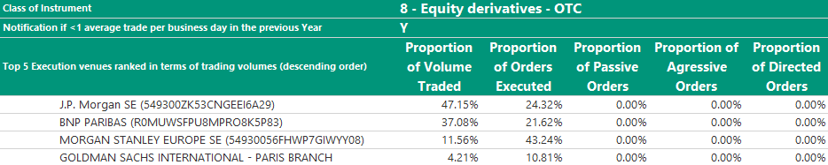

We traded over the counter (OTC) swaps and Equity Derivatives in this category of financial instrument.

Our traders focus mainly on price, and request RFQ’s from different counterparties depending on where they expect liquidity to be available. In order to complete orders, liquidity can be a factor in relation to less liquid swaps or large in size orders.

In the top 5 execution venues, J.P. Morgan is the first counterparty with more than 47% of volumes and 24% of executed orders. BNP Paribas dealt with 37.08% of volumes and 21.62% of orders. Morgan Stanley with 11.56% of volumes and 43.24% of orders. Goldman Sachs had less than 5% of volumes but 10.81% of executed orders.

As with other OTC products, our list of authorized OTC derivative Counterparts comprises major banks that have satisfied our criteria to protect clients from settlement risk and includes the execution of ISDA/CSA documentation to support Bilateral trading or Clearing agreements.

We have adapted our trading architecture so that we are ready to meet modified US and European regulations which require changes to how we clear, trade, report and record eligible derivative contracts.

## 

## Contract For Difference

Executions on CFD instruments are generally driven by the price and order size, and then market liquidity and conditions, speed of execution and likelihood of settlement.

Depending on the parameters of the orders (Buy, Sell, Open or Close of position), traders may have to deal with the prime brokers.

1. **Transmission report**

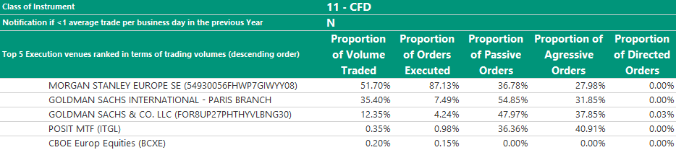

For this chart, we have traded again with prime brokers. Morgan Stanley is the first counterparty with more 51% of volumes and 87.13% of executed orders, Goldman Sachs International with 35.40% of volumes and 7.49% of executed orders. Goldman Sachs & Co. LLC is the third with 12.35% of volumes and 4.24% of executed orders.

## EXchange traded products

Executions on Exchange Traded Products are generally driven by the price and order size, and then market liquidity and conditions, speed of execution and likelihood of settlement.

A part of the ETP, orders are transmitted to brokers. Depending on the parameters of the orders, traders may have to execute and in this case, they perform an RFQ process to get the best possible results. This is the case, in particular for ETF with the type of order "NAV guaranteed”.

To perform its controls for ETF, Dealing Services uses a ‘RFQ’ report highlighting competing quotes received from counterparties (including justifications when execution prices differ from best quotes of if there have been insufficient number of quotes).

Execution quality is regularly reviewed by Dealing Services desks (first level controls), Compliance teams (second level controls) and with the client ‘s investments strategy teams.

1. **Execution report**

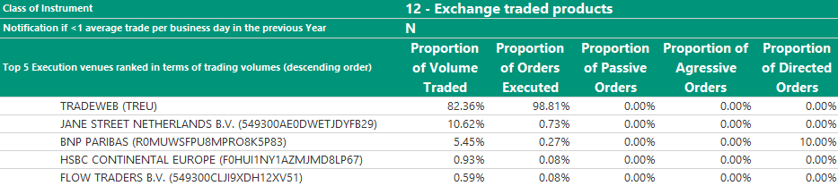

Tradeweb is the number one with around 82% of volumes and 99% of executed orders being the main platform for RFQs. The other counterparties provided axes, which helped us to supply efficiently with liquidity.

Top 5 counterparties on Tradeweb

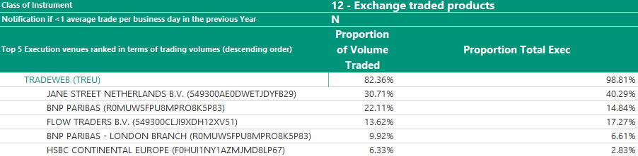

Jane Street with almost 31% of volumes has slightly increased this year its market share and number of trades. BNP Paribas has increased its volumes with 22.11% but the proportion of executed orders has decreased to 14.84%. The other specialized Market Makers in ETD, Flow Traders, BNP Paribas and HSBC represent 40% of the remaining volume and 26% of the executions.

1. **Transmission report**

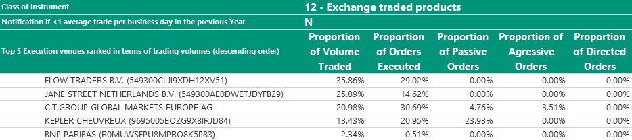

For the transmission report, Flow Traders is first with 35.86% in terms of volumes and 29.02% in terms number of executed orders. Jane Street is at around 26% of volumes and 15% of executed orders. Citigroup and Kepler also participated in the reception and transmission of orders.

BNP Paribas entered the top five this year and is ranked last with 2.34% of volumes and 0.51% of executed orders.

# 

# SECURITIES FINANCING TRANSACTIONS (SFT)

## Repo and Reverse Repo

1. **Execution report**

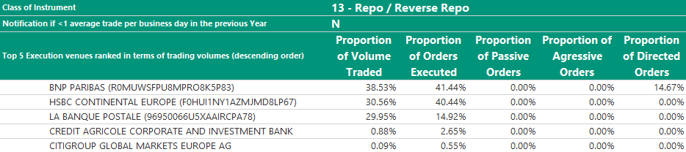

This year on Repo / Reverse Repo, BNP Paribas is the first counterparty with 38.53% of volumes and more than 41% in terms of orders executed. The portion of volume traded by HSBC and La Banque Postale amounted 31% and 30% respectively while the number of executed orders is 40% and 15%.

Executions on Repo/Reverse repo instruments are generally driven by the price and order size, and then market liquidity and conditions, speed of execution and likelihood of settlement.

All the activity is done off venue (telephone, IB Chat), due to the nature of the instruments. As much as possible, the traders do an RFQ process if it does not lead to information leakage on the market.

In some cases, Dealing Services may not be in a position to organise a request for quotes or may consider that it is inappropriate to do so in the client's interests, which provides a de facto justification that the price criterion has been adhered to.

Without drawing up a comprehensive list, this may occur in the following circumstances:

* a need to guarantee maximum confidentiality;
* the illiquidity of the financial instrument;
* any situation where the request for quotes is contrary to the clients' interests.

To perform its controls on repo/reverse repo transactions, Dealing Services uses a ‘RFQ’ report highlighting competing quotes received from counterparties (including justifications when execution prices differ from best quotes of if there have been insufficient number of quotes).

Execution quality is regularly reviewed by Dealing Services desks (first level controls), Compliance teams (second level controls) and with the client ‘s investments strategy teams.

# DISCLAIMER

BNP Paribas Dealing Services, a French limited company (“société anonyme”) registered with the Paris Trade and Companies Register under number 454 084 237, is authorised and supervised by the Autorité de Contrôle Prudentiel et de Résolution (“ACPR”) and the Autorité des Marchés Financiers (“AMF”).

This material is issued and has been prepared by BNP Paribas Dealing Services.

This material is produced for information purposes only and does not constitute:

An offer to buy nor a solicitation to sell, nor shall it form the basis of or be relied upon in connection with any contract or commitment whatsoever or an investment advice.

The information about the passive or aggressive nature of an order is provided by the brokers and counterparties. The quality of these information cannot be verified by Dealing Services which shall not be responsible or liable in any way for the content of these information.